Children’s Commissioner for England
Sanctuary Buildings
20 Great Smith Street
London
SW1P 3BT

Dear Rachel,

We are deeply concerned to hear that public libraries across the UK are hosting Drag Queen Story Hour events at which men dressed as grotesque versions of women will read stories to children of primary school age. This is presented as entertainment though it masks a political agenda. Drag Queen Story Hour began in the United States and from the beginning stated that its goal is to promote ‘queer role models’, ‘LGBTQ+ herstories’ and the ‘gender fluidity of childhood’.
Even if we were to treat these events as purely entertainment, they would be highly inappropriate for children 3-11 (the stated target audience) given that the images of men dressed as women are highly sexualised. Many may also regard these as negative stereotypes. Drag shows are adults-only entertainment and not suitable for school age children. When we expose children to sexual material, we blur the boundaries between adults and children, exposing them to adult sexual concepts and we risk normalising the sexualisation of children.
Drag Queen Story Hours pose as entertaining and educational events but their central purpose, as their stated goals above show, is neither entertainment nor education but indoctrination in the transgender agenda.
Children in primary school are at the most vulnerable stage of their development. While young people will inevitably become aware of the existence of transgender lifestyles at some point in their development, it is never age-appropriate to teach about such relationships in primary school.
What makes this initiative particularly disturbing is its use of those involved in adult entertainment to indoctrinate children in the transgender agenda, while trying to present the whole affair as a wholesome family friendly event.
In response to concerned parents booking blocks of tickets for the library tour dates on the release this week, the man behind DQSH UK, Sab Samuel, who performs as “Aida H Dee” described them as “Nazis” and set up a fundraiser for the charity Mermaids, which promotes puberty blockers and surgery to “transgender children”. While children suffering with gender dysphoria need appropriate support and therapy, telling parents they must either affirm their child or they will commit suicide is not only incredibly irresponsible and harmful, but based on false statistics. Previous studies show that if left to go through natural puberty, the vast majority of children with gender dysphoria will be happy in and with their natal sex.
As outlined by the MP Miriam Cates in the recent debate on RSE materials in schools, the 4000% rise in teenage girls referred to the NHS gender services clinic is highly suggestive of social contagion among children and is a real problem. The interim report by Dr Hilary Cass found that “social transition is not a neutral act” and urges caution in the treatment of children suffering with gender dysphoria. Indeed, in his role as health secretary, Sajid Javid had announced a review into NHS gender services due to the overwhelming concern about the harm being done to children.
One of the most disturbing things about the transgender agenda is the way that it tries to distort our perception of reality and deny something as fundamental as the distinction between male and female.
To try to blind children to one of the most basic facts of human existence can only be described as a form of child abuse. We are already seeing a substantial rise in the number of children who identify as transgender, largely due to the sympathetic and positive treatment of the issue on children’s TV. This has had tragic consequences in, for example, the Keira Bell case. Such confusion is only likely to increase if we start playing with children’s minds in venues such as libraries.
Children believe what adults tell them – so to have adult men dressing as women telling them that “love has no age” and that children can be “born in the wrong body” is deeply worrying.
Children who experience gender identity issues need careful and sensitive care, not wholesale indoctrination. Making primary school children the central target for proselytism in advancing the agenda of a small minority has got to stop.
The local library is supposed to be a family friendly environment where parents can take their children without fear that they will be exposed to inappropriate material. Libraries generally take strong precautions to ensure the safety of children, so it is extremely alarming to see the very poor safeguarding document produced by Drag Queen Story Hour. The document contains no definitions of terms, no links to local authority procedures or contacts, limited explanation of the duty to share information relating to safeguarding and how this interacts with confidentiality.
It approaches safeguarding from the viewpoint of DQST staff being the risk, rather than the very real possibility that a child makes an unexpected disclosure or DQST observe behaviour of concern.
Effective context specific safeguarding policies should refer to the "service" provided and should in this context include guidance on:
- Age-appropriate reading material
- boundaries and physical contact between the performer and children
answering questions
- dress code
- never being alone with children
- not exchanging contact details
- adult / parental supervision
- online presence of the performer and suitability for children
- Age-appropriate language / use of euphemisms
- Safe recruitment / levels of due diligence needed by commissioners for example checks/enhanced DBS /online material checks
Safeguarding policies are only useful when they help those implementing them to understand what safeguarding children actually looks like within the context they're working in. The Drag Queen Story Hour document fails to do this.
We would urge you to continue to protect families and children by ensuring that the Drag Queen Story Hour will not take place at any libraries, schools or literary festivals where children are the audience.
We hope you will engage with us on this issue, and we look forward to hearing from you.
With kind regards,

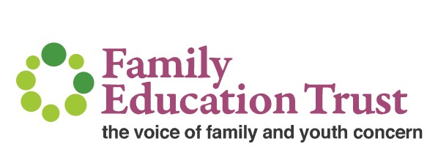

Dr Julie Maxwell, Trustee of the Family Education Trust
and NHS Consultant Paediatrician

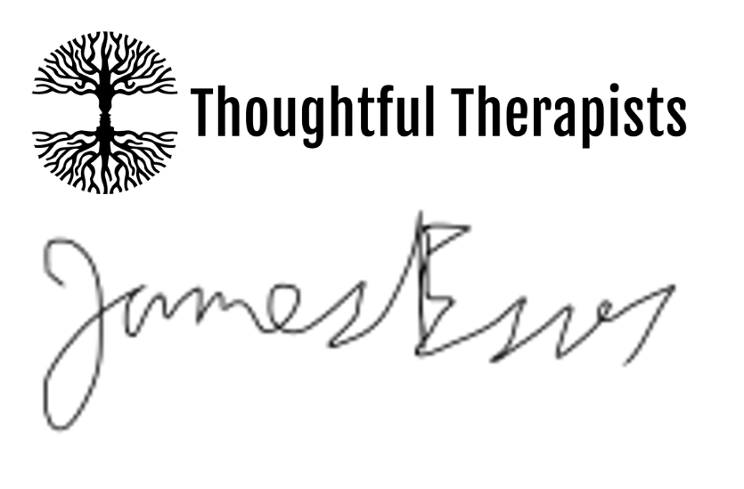
James Esses, Founder of Thoughtful Therapists

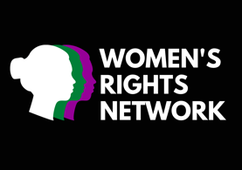
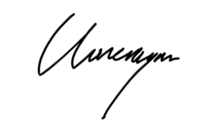
Claire Loneragan, on behalf of Women’s Rights Network

